- List employees with their department name & location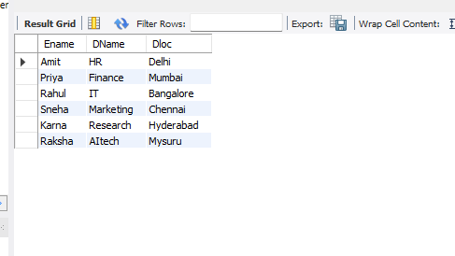
- Employees who are not assigned to any project ,Project-wise headcount
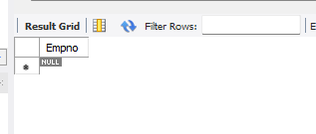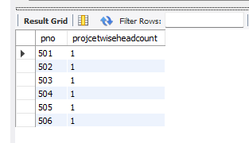
- Department-wise average & max salary
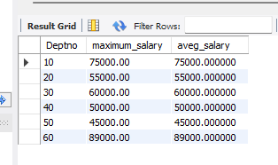

- Total incentives earned by each employee (lifetime)
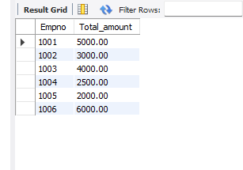

- Employees working on a given project (project name :Alpha Project)
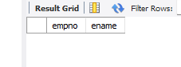
- Departments with no employees
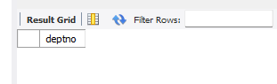
- Managers and their direct report counts (MGR_NO references EMPNO)
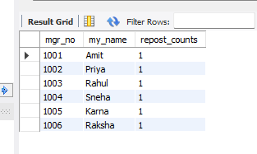
- Employees assigned to more than one project.
